|  |  |
| --- | --- |
| Lab 7 Report | Antonio Zavala Anaya  UTEP ID 80622587 |

|  |
| --- |
| Project Name: Lab_7 (GitHub Repo)November 2019 |
| * Purpose: Write a Python 3 program that Implement the following dynamic-programming algorithm: * Edit Distance   By doing at least one of the following to test your implementations:   * Unit Tests * Creating a separate file where you call your implementation using hard-coded strings |
| * Process:   + In the edit.distance class file we create a 2D array to store both strings.   + Fill the first row and column using both strings   + Using nested for loops we acknowledge how many changes are going to be needed to change the first string into the second one.   + If the character is equal for both the value on the diagonal is used otherwise the lowest value around the slot in the array is used plus one.   + At the end the value at the bottom right is the total number of changes needed to change the string and that is the value returned.   + The main method class file is used to try several test cases. * Files used that will be used: * Edit_distance.py * main.py |

* Lab_5 program codes
* **Edit_Distance**

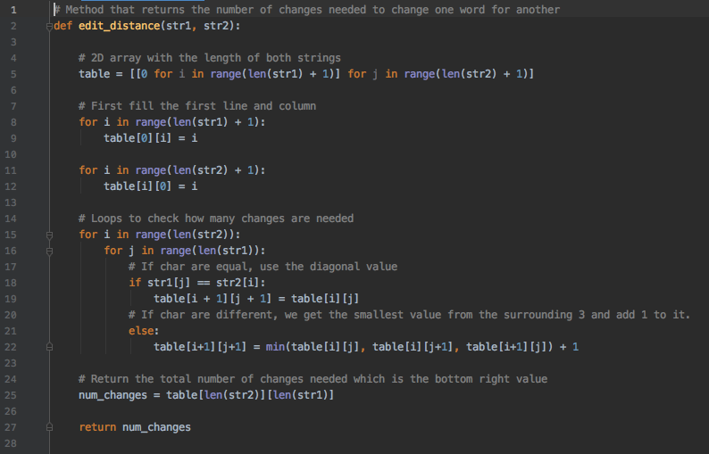

* **Main**

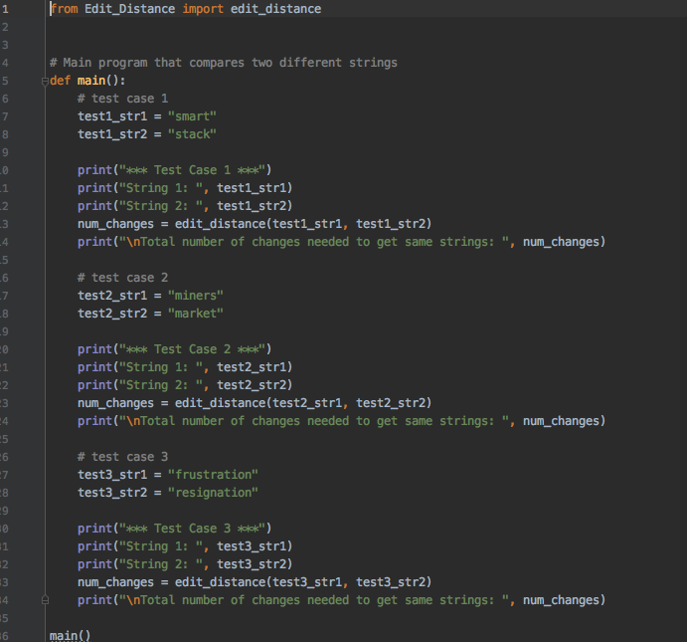

* Test Cases
* Test case 1

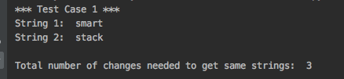

* Test case 2

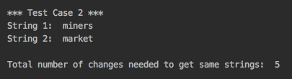

* Test case 3

